July 25, 2023
COLLABORATION MEETING GROUP NOTES
Welcome
- Elizabeth Raue
- Naomi Vega
- Angela Nasewytews
- Adriana Aquina
- Elizabeth Stamm
- Jack Julsing
- Mayra Jeffry
- Dedra Clark-McGee
- Sarah Graham
- Cheyenne Watson
- Mark Person
- Alex Fernandez
- Arisia Lee
- Shawn Wool
- William Baer
- Moe Hill

Data
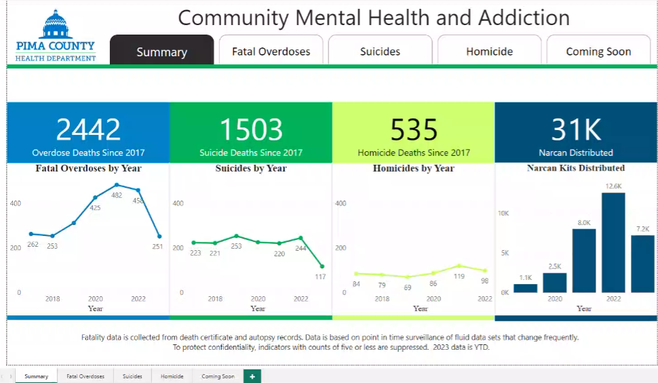
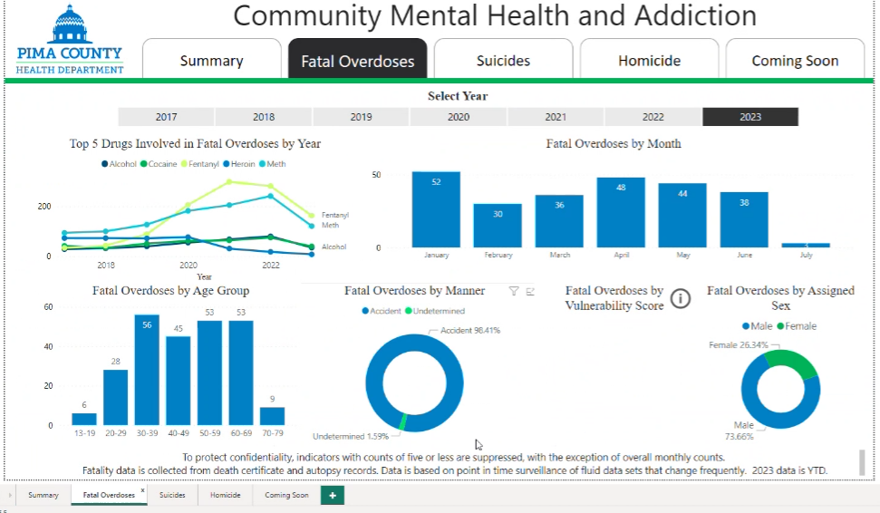
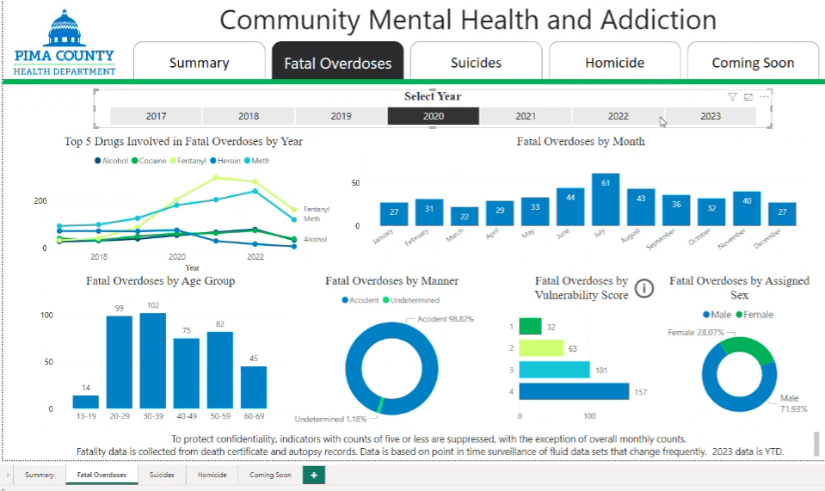
- The Pima County Health Department’s Interactive Dashboard tracks overdoses among other things. In this meeting we’ll discuss deaths due to overdoses.
  - This is surveillance data (not precise counts – counts things as they occur. Point in time count. Not official counts. Counts will not go lower, only up).
- Fatality data
  - By year the number of fatal overdoses in Pima County is 2442 since 2017.
- Fatal Overdoses tab
  - Top 5 by drug type.
    - Alcohol, Cocaine, Meth, Heroin.
      - Most common.
    - 2022
      - Fentanyl - 281
      - Meth - 241
      - Alcohol - 80
      - Cocaine - 75
      - Heroin - 18
    - 2023
      - Fentanyl - 163
      - Met - 121
      - Cocaine & Alcohol – flip flopped.
        - 5 away from one another.
      - Heroin - 8
        - Now really low, used to be close to the top.
        - In 2017 Heroin was at 273 and Meth was close to it.
        - When fentanyl came on the scene, it replaced Heroin.
        - In 2021, the year ended with Heroin at 31.
        - Currently at 8 right now, will probably remain the same. It is not used as much as Fentanyl and Meth. Fentanyl has replaced it and it is widely available.
    - Naomi: When we are looking at the data, is it referring to polysubstance use?
      - Mark: It is frequently listed as polysubstance.
        - 163 deaths for Fentanyl – some were only fentanyl, and some were polysubstance.
        - In 2022 the overdose deaths was 456. This number is the total number of decedents. How many died of a drug overdose.
    - Naomi: There is a rise in age groups 50-69.
      - Is there anything we are doing to reach that target population?
  - In January CMHA sent out a health alert for fatal overdoses by month.
  - We recently sent out a heat alert.
    - Majority of heat related deaths in Pima County occur indoors.
    - Folks die at home because utilities are not functioning or were turned off because of the cost.
  - Age Groups Data
    - 2020
      - Top 2 groups were ages 20’s & 30’s.
    - 2021
      - Overdose deaths in the 20’s age group went down.
      - Deaths in the 40’s & 50’s age groups crept up slightly
    - 2022
      - Deaths in the 20’s age group came down again (almost 50% reduction).
Deaths in the 30’s age group went down slightly.
      - Deaths exceeded 100 in 50’s age group.
        - The 60’s age group had 54 deaths.
    - 2023 –we are 6 months into the year.
      - As of right now there are 53 deaths in the 60’s age group, this is almost the entire total from the previous year.
        - This age group didn’t fluctuate this much in past years.
          - What is driving the changes?
            - Don’t have an answer.
            - Same drugs are being used.
            - More pharmaceuticals.
            - Same policy control measures for opioids and analgesics.
            - Same stressors.
            - This is traditionally an age group close to retirement with unique stressors that develop.
            - Nothing is jumping out at us.
            - It could be heat related, but the overdose deaths started before summer began.
            - This is a time this Collaboration group is really beneficial, because it gives us a chance to talk to you guys to glean insights from you.
            - We talked to PCOA recently.
            - It will really take the efforts of the community to figure out what is contributing to the deaths.
      - Big change in deaths in the 60’s and 70’s age groups.
  - It looks like cocaine is increasing as we look at the records and the fatality review to see if anything stands out. Are you guys seeing cocaine coming back? Have you seen cases involving crack cocaine? Are you hearing similar things?
    - Alex: We met with Lieutenant Brady. He mentioned that he’s seen more people overdosing on xylazine. How can you tell if someone has had fentanyl with xylazine?
    - Mark sent out an advisory a couple months ago.
      - It breaks down the tissue and it looks like a flesh wound.
      - The wound doesn’t have to be at the site of the injection(s), it could be anywhere. Someone who has used it daily for a while will have wounds.
      - Used for small procedures on small animals.
      - Wounds are an indicator.
      - Wound care at the hospital level might be an identifier.
    - Testing
      - Do we test for xylazine?
        - It is a drug veterinarians use.
        - Medical examiner here and in Maricopa do test for it.
        - Maricopa tests for it for all overdose cases
        - Pima County tests for it for some overdose cases
        - Xylazine is mixed with fentanyl.

