Meeting Notes
Collaboration Meeting Group
Tuesday, October 24, 2023
2:00-3:00 pm
TEAMS

Attendance
Shawn Wool CODAC
Brock Pennington Cornerstone Behavioral Health
Hailey Owen AZ Complete Health
Claudia Adams AZ Complete Health
Angela Nasewytewa Tucson Indian Center
Jennier L. Kent AZ Complete Health
Mayra Jeffery PCHD
Arisia Lee PCHD
Mark Person PCHD

Welcome/Overview of Today’s Meeting
- Arisia Lee
AZ Complete Health Update
- Claudia Adams
  - AHCCCS has notified that the Substance Use Prevention, Treatment and Recovery Services Block Grant (SABG) will implement a name & acronym change from SABG to SUBG which is Substance Use Block Grant.
  - No wrong door for members needing substance use or mental health services. Funding can be screened for individuals for SUBG and MHBG coverage if they should not qualify for AHCCCS or should lose their AHCCCS coverage. Also, we are currently in the midst of completing SUBG and MHBG ARPA proposals to sustain current programming and attend to new proposals+expansions.
  - If there are any community needs at this time, let Claudia know at claudia.adams@azcompletehealth.com.
- Hailey Owen
Helps to oversees the State Opioid Response grant for Southern Arizona. We have a no wrong door policy for finding resources for opioid use. If more information or connections are needed, contact Hailey at hailey.owen@azcompletehealth.com.
Data Sharing
Mark Person, PCHD
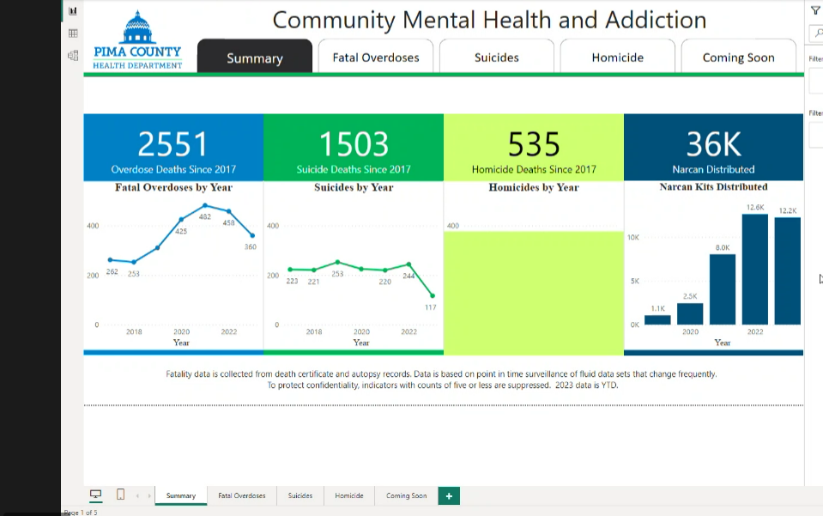
- Not a lot of changes in the data since last month’s meeting.
- Fatal overdose trends are from overdoses that occurred in Pima County. This includes all people that passed away from an overdose in the jurisdiction of Pima County even if they are visitors and residents of Pima County. If a Pima County resident passes away from an overdose outside of Pima County, their death is not recorded.
- Please note that this is surveillance data and it changes daily.
Top 5 Drugs Involved in Fatal Overdoses by Year
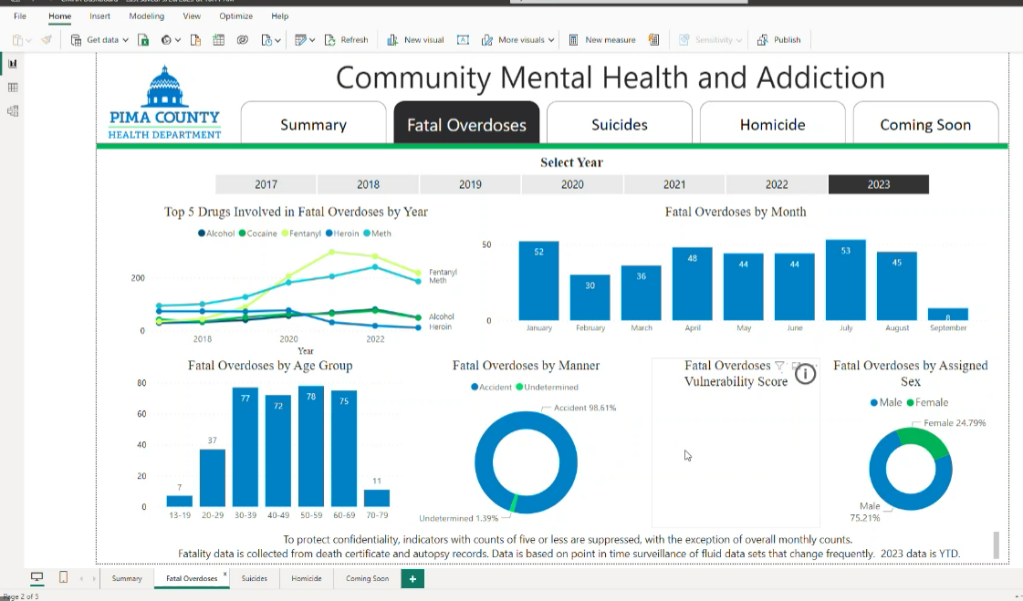
- Alcohol, cocaine, fentanyl, meth, and heroin are the top five drugs.
- Fentanyl and meth make up almost 85% of all overdose deaths.
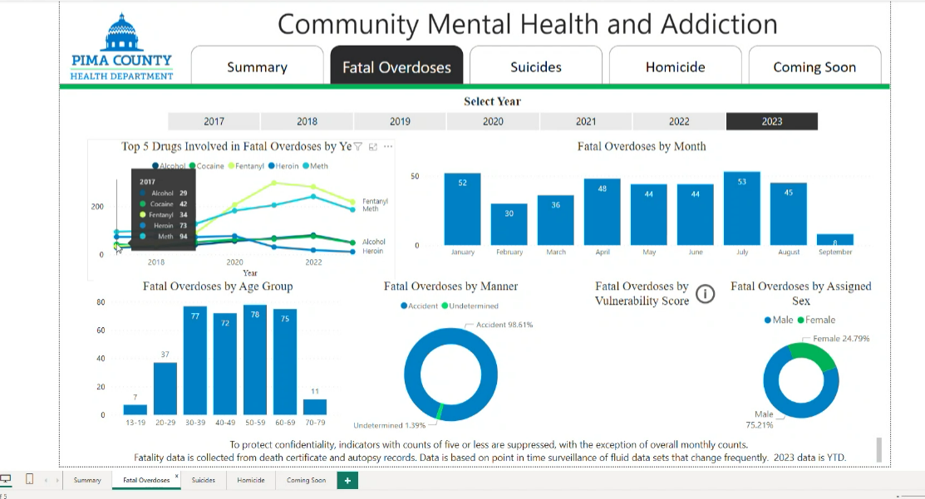
- In 2017 alcohol, cocaine, and fentanyl had lower numbers than heroin and meth. At this point fentanyl was not a major factor and the total number of deaths due to fatal overdoses was 262.
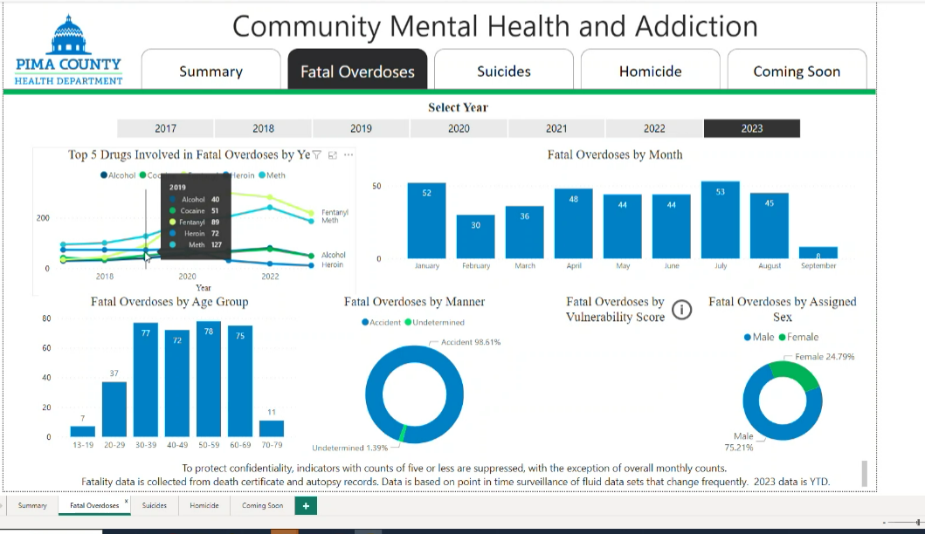
- In 2019 meth spiked and overdose death due to fentanyl doubled and was at 89 deaths. This was the first year that fentanyl surpassed heroin.
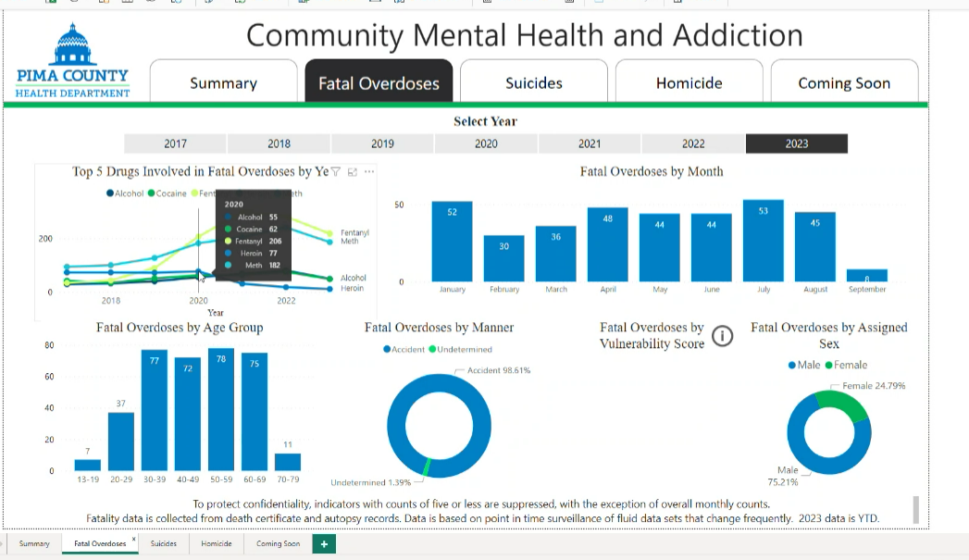
- 2020 saw a surge in overdose deaths and deaths due to fentanyl. 206 overdose deaths in 2020 were caused by fentanyl. 2020 also saw an astronomical increase in number of deaths from heroin.
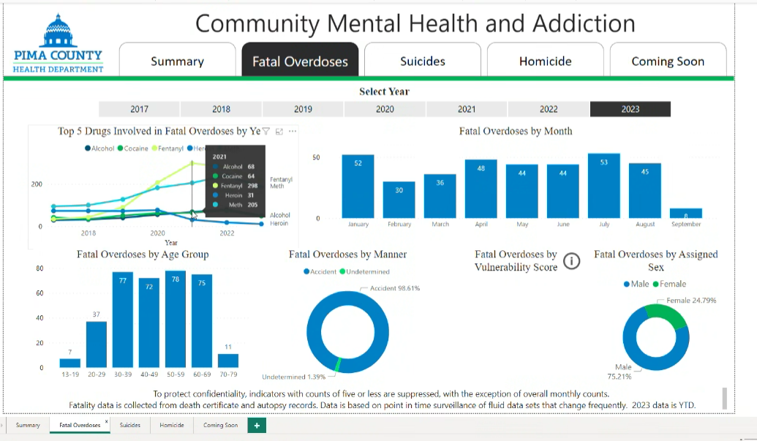
- 2021 was the worst year in record in Pima County for deaths caused by overdoses. The total number of deaths caused by overdoses in 2021 was close to 500. In 4 years’ time overdoses caused by meth continually increased and fentanyl really began to take off, causing the perfect storm of high totals of overdose deaths that had not been seen in the past. In this year overdose death totals due to fentanyl reached 298 deaths, which accounted for more than half all-overdose deaths. Deaths due to fentanyl alone in 2021 surpassed 2017’s total number of deaths. 2021 also saw 205 overdose deaths from meth, the highest from 2017 through 2022.
- 2022 saw some decrease in younger age groups, but the total of overdose deaths remained high. Heroin was way down in 2022 and was almost phased out completely.
- Thus far in 2023 deaths due to heroin remain low at 11 deaths. Fentanyl currently is at 218 deaths for the year and meth is at 186 deaths.
- Due to data lags, reporting is reflective of about three quarters of the year.
Fatal Overdoses by Month
- Thus far in 2023, January has had the greatest number of deaths due to overdoses. This high number resulted in the health department sending out an alert to the community.
- The next month in 2023 with the highest amount of overdose deaths was in July at 53 deaths. The numbers for both January and July are huge numbers, the highest numbers before this year that was seen was in the 20’s.
- What we are looking at based on projections is comparable to last year’s numbers and may even surpass last year. We anticipate either meeting or exceeding the total of 2022.
Fatal Overdoses by Age Groups
- The age group with the highest overdose deaths have changed frequently since 2017.
- Currently all demographics getting hit by this crisis.
- 2017 saw a gradual uptick with small numbers.
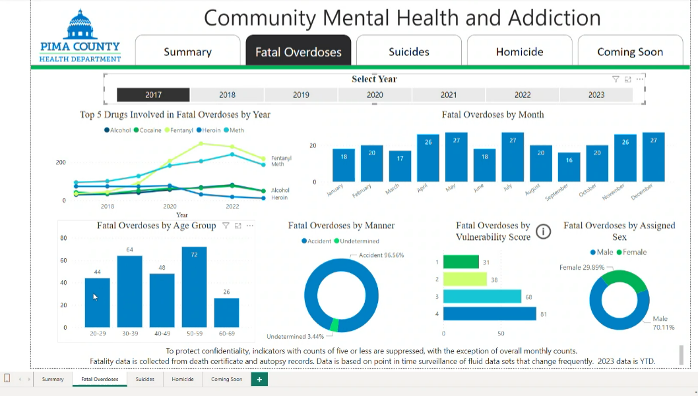
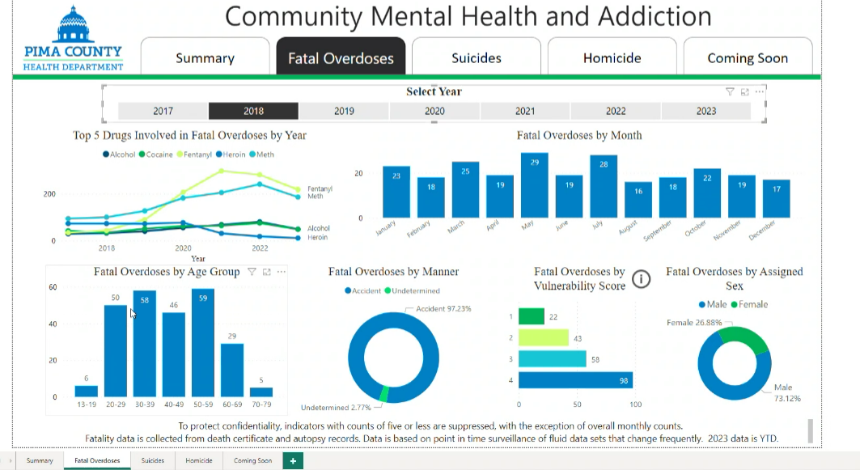
- 2020 had some age groups in the 100s. In this year teens were hit hard and deaths of people in their 30’s sky rocketed to 123 deaths.
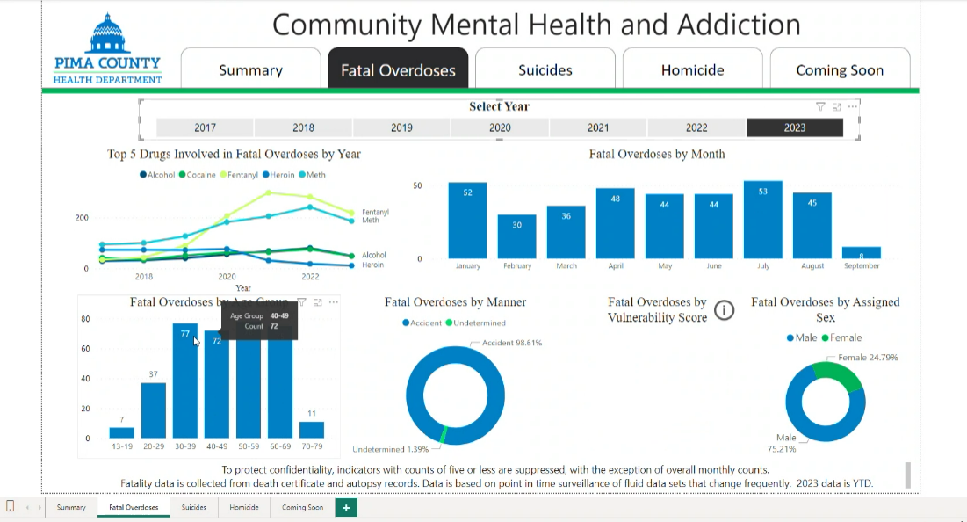
- In 2023 all age groups high and since 2023 has not ended, it is expected that most age groups will reach 100 deaths. The biggest changes that are being seen in 2023 are for deaths of people in their 50s and 60s.

Action Plan Update
CODAC
- We have continued to attend community events.
- Recently we were at the Fresh Start Expo at the Tucson Community Center. Over 1000 people were there and a lot of agencies set up tables and there were events and speakers.
- CODAC reached out to High Schools and Middle Schools and presented to students. Information and services were also provided.
- Wednesday outreach continues. Brock from Cornerstone Behavioral Health has provided valuable help with coordination and services.
- The need in the community is there. Finding resources is challenging and we are meeting people where they are and working with community partners.
- Challenges are a shift in homeless. We are seeing more substance misuse and less mental health issues.
- Our current outreach efforts have shifted to Swan and Valencia on State Trust Lands. Unhoused people have moved from the 100 Acres area to this area. Our focus has been to offer services to the people in this area. The people in this area have figured out that when outreach begins to show up to the area that they are occupying that they will soon have to move out of that area.
Cornerstone Behavioral Health
- We went to the state property last week at Swan and Valencia and are offering MAT and detox services.
- El Rio has been offering medical services.
- The people we have been offering services to have been struggling to get on AHCCCS because they have to file for unemployment when previously they could submit a letter. In these cases we direct them to go to the DES office in person so they can sign up for unemployment.
- The VA has sponsored a coalition comprised of organizations and community members. They are trying to create a full spectrum of services - residential, output, jiu jitsu, spiritual counseling, HOPE Inc., CRC, and identify veterans to give them a warm handoff from organization to organization.

Healthy Pima Update
- Arisia Lee will be leaving Healthy Pima and Caroline Lewis will now be overseeing Healthy Pima.
- If you have anything you would like to add to the Healthy Pima Newsletter, email Arisia Lee at Arisia.Lee@pima.gov.

Wrap Up
- Arisia Lee, PCHD

Next Meeting: November 28, 2023
AZ Complete Health update, Data Sharing

